

**Police surgery**

–

Cuxton

&

Halling

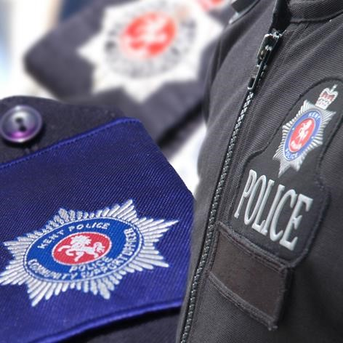

Your local officers will be

holding a police surgery

on:

**Friday 27**

**th**

**January 2023 between**

**16:00 and 17:00 at**

**Cuxton Library**

**Bush Road**

**Cuxton**

**Kent**

**ME2 1EY**

**Come and speak to local officers about your**

**concerns on crime and anti**

**-**

**social behaviour**

Your local officer **PCSO Kailey Norton** will see people individually on a first come, first served basis.

For more information, please contact your local policing team by calling **101**.Please see notice board for future dates and any changes. For news, safety advice and information about policing in your area, visit [**www.kent.police.uk**](http://www.kent.police.uk)

**Protecting** and **serving** the people of Kent