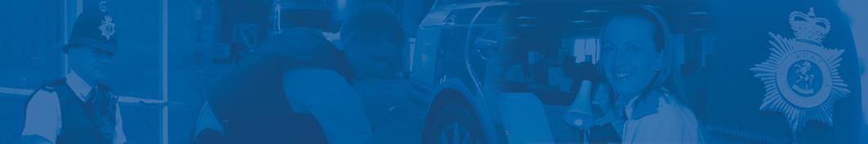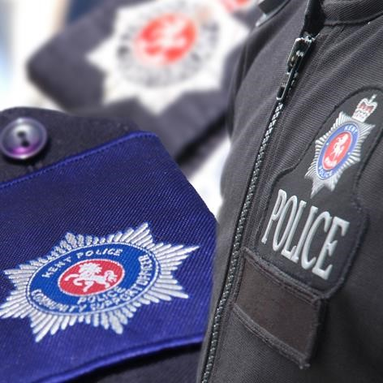
Police surgery
–
Cuxton
&
Halling
Your local officers will be
holding a police surgery
on:
Friday 10
th
March 2023 between
16:00 and 17:00 at
Cuxton Library
Bush Road
Cuxton

Kent
ME2 1EY
Come and speak to local officers about your
concerns on crime and anti
-
social behaviour
Your local officer PCSO Kailey Norton will see people individually on a first come, first served basis.
For more information, please contact your local policing team by calling 101.Please see notice board for future dates and any changes. For news, safety advice and information about policing in your area, visit www.kent.police.uk
Protecting and serving the people of Kent

